
MAGNA COLLEGE OF ARTS AND SCIENCE
Redhills – Tiruvallur High Road, Magaral, Chennai-55

Department of Computer Applications

Tamil Nadu Skill – Project

AI WEATHER WISE API

YOGISHWARAN S - 212406241
BOOBALAN S – 212406226
JAYASUDHA M – 212406243
SANJAY M - 212406232
MALLISWARI M - 212406246

Batch – 2024–27

AI WEATHER WISE API

ABSTRACT
AI Weather Wise API is a web-based application designed to collect and display weather information for a selected location. The project uses a Weather API to obtain details such as temperature, humidity, wind speed, atmospheric pressure, rainfall and general weather condition.

The application receives structured data in JSON format, extracts the required values and presents them in a simple format. The report also describes how Artificial Intelligence and Machine Learning can be added in future versions for weather pattern analysis and prediction.

INTRODUCTION
Weather is an important part of daily life because temperature, rainfall, humidity, wind and atmospheric conditions affect agriculture, travel, transportation, education and outdoor activities. People therefore need weather information that is quick to access and easy to understand.
Traditional sources such as newspapers, television and radio provide weather updates, while websites and mobile applications provide faster digital access. An API-based application provides another approach: it allows software to request information from a weather service and then present only the details needed by the user.
AI Weather Wise API follows this basic idea. The user supplies a city or location. The application creates a request, the Weather API processes it, and a structured JSON response is returned. The application then extracts the required fields and displays them.

PROBLEM STATEMENT
AI Weatherwise is designed to provide weather information in a simple and intelligent way. Users often find it difficult to collect weather details from different sources and understand technical weather information. Developers also need an easy and reliable method to integrate weather services into applications.
The major problems are:
- Weather information is available from different sources and platforms.
- Users may find technical weather data difficult to understand.
- Important weather details are not always presented in a simple format.
- Developers need an API to easily integrate weather information.
- Analysing large amounts of past weather data manually is time-consuming.
- Basic weather applications may not provide intelligent insights or analysis. The proposed AI Weatherwise application uses a Weather API and AI-based analysis to collect, process, and present weather information in a clear and user-friendly manner. It helps users understand current and historical weather data more easily.
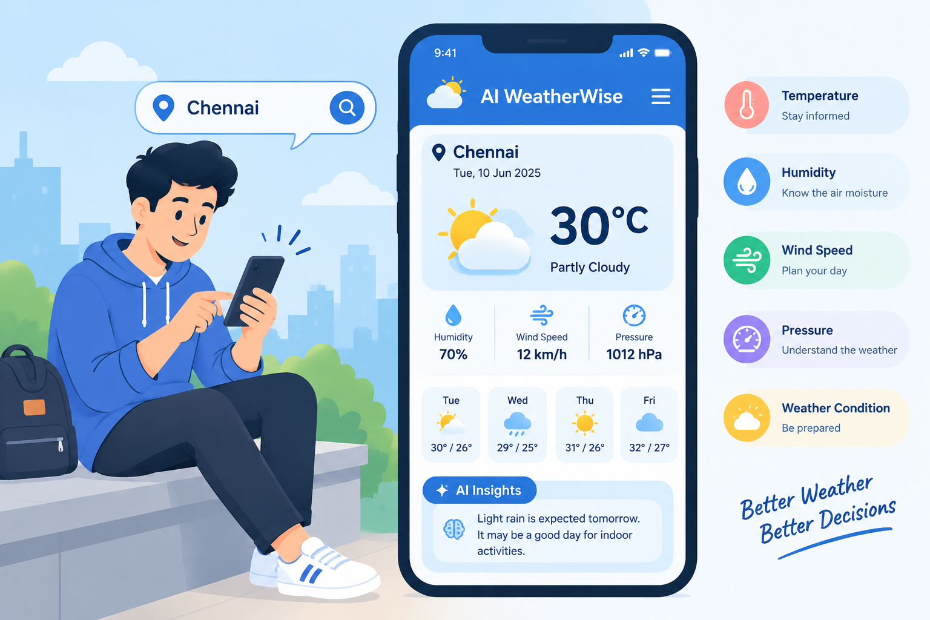

OBJECTIVES
- To provide accurate weather information for a selected location.
- To enable users to search for weather details using a city or location name.
- To integrate a reliable Weather API with the application.
- To display temperature, humidity, and other weather conditions clearly.
- To provide information about wind speed, pressure, and visibility.
- To present weather details through a simple and user-friendly interface.
- To collect and process weather data in JSON format.
- To organize weather information for quick and easy understanding.
- To use AI techniques for analysing weather data and generating useful insights.
- To help users access important weather information quickly and conveniently.

EXISTING SYSTEM
Existing ways of obtaining weather information include television weather reports, newspapers, search engines, weather websites and mobile weather applications. These sources can provide current weather information to general users.

A conventional user-focused approach is mainly concerned with showing weather information. A developer-focused requirement is different: the information must also be available in a structured form that a program can request and process.

LIMITATIONS OF EXISTING SYSTEM
- Weather information may be available across multiple websites or applications.
- Users may have difficulty finding all required weather details in one place.
- Some existing systems provide only basic weather parameters.
- Understanding and analysing historical weather data can be time-consuming.
- API availability and compatibility may limit application integration.
- Many basic weather applications provide limited data interpretation.
- Existing systems may not provide AI-based insights from weather data.
- Weather information may not always be presented in a simple and user-friendly format.

PROPOSED SYSTEM
The proposed system is called AI Weather Wise API. It is designed to receive a city or location from the user, communicate with a Weather API, process the returned JSON data and present the required weather information.

- User enters a location.

- Application prepares an API request.

- Weather API receives the request.

- Weather server processes the location.

- JSON data is returned.

- Application extracts selected values.

- Weather information is displayed.

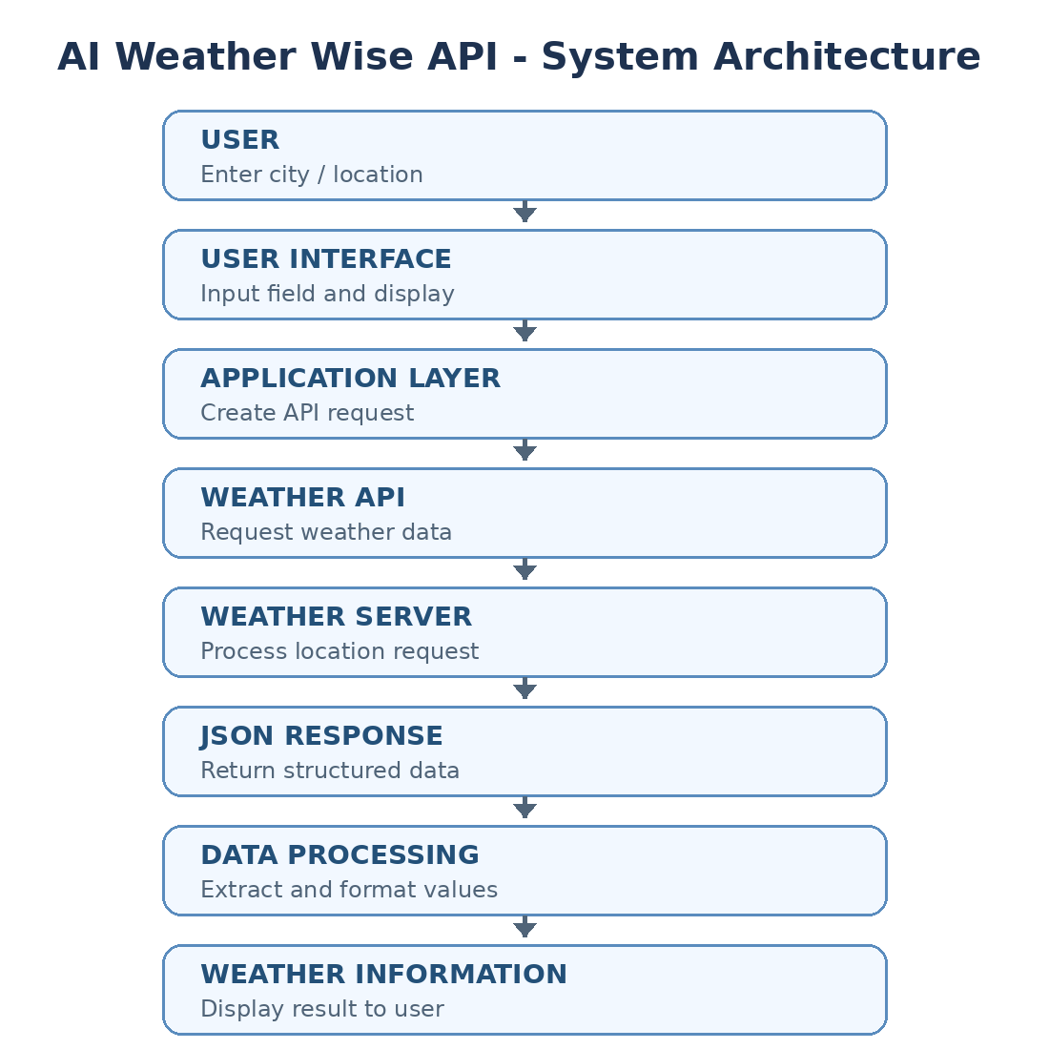

ARTIFICIAL INTELLIGENCE IN WEATHER ANALYSIS
Artificial Intelligence (AI) helps computer systems process weather data and identify meaningful patterns. In AI Weatherwise, AI can be used to analyse current and historical weather information and provide useful insights to users.
Applications of AI in Weather Analysis
- Weather condition classification – Identifies conditions such as sunny, cloudy, or rainy.
- Weather pattern identification – Finds patterns and changes in weather data.
- Unusual condition detection – Helps identify unexpected weather conditions.
- Forecast support – Analyses available data to support weather forecasting.
- Historical weather analysis – Studies previous weather records to understand trends.
For example, temperature, humidity, and rainfall data from previous days can be analysed to identify recurring weather patterns. These patterns can be used as input for Machine Learning models to generate useful weather insights.

WEATHER API
API stands for Application Programming Interface. A Weather API allows an application to obtain weather information from an external weather service.
For example, the user enters:
City: Chennai
The Weather API may return data in JSON format:
{
"city": "Chennai",
"temperature": 30,
"humidity": 70,
"wind_speed": 12,
"condition": "Cloudy"
}
The AI Weatherwise application receives the JSON data, processes the required values, and displays them in a simple and understandable format.
Simple Working Flow
User → AI Weatherwise → Weather API → JSON Data → Data Processing → Weather Information → AI Analysis

ADVANTAGES OF API
- Easy Data Access – Provides weather information in a structured format.
- Simple Integration – Makes it easier to connect the application with external weather services.
- Fast Response – Retrieves weather information quickly from the server.
- Application Communication – Allows the application to communicate with external services.
- Real-Time Information – Helps obtain updated weather information.
- Flexible Usage – Can be integrated into websites, mobile applications, and other software systems.
- Reduces Development Effort – Developers can use existing weather services instead of creating a weather database from scratch.

SYSTEM ARCHITECTURE
The AI Weatherwise system consists of several components that work together to collect, process, analyse, and display weather information. The user enters a location, the application sends a request to the Weather API, and the received data is processed and displayed in a simple format.
Components
- User Interface – Allows the user to enter a city or location and view weather information.
- Application Layer – Processes the user's request and sends the required API request.
- Weather API – Provides weather data for the selected location.
- Weather Server – Receives the request and retrieves the required weather information.
- JSON Response – Transfers weather data from the API in a structured format.
- Data Processing – Extracts and organizes the required weather values.
- AI Analysis – Analyses weather data to identify patterns and provide useful insights.
- Weather Display – Presents the processed weather information clearly to the user.
SYSTEM ARCHITECTURE DIAGRAM
+----------------------+
| USER |
+----------------------+
↓
+----------------------+
| User Interface |
+----------------------+
↓
+----------------------+
| Application Layer |
+----------------------+
↓
+----------------------+
| Weather API |
+----------------------+
↓
+----------------------+
| Weather Server |
+----------------------+
↓
+----------------------+
| JSON Response |
+----------------------+
↓
+----------------------+
| Data Processing |
+----------------------+
↓
+----------------------+
| AI Analysis |
+----------------------+
↓
+----------------------+
| Weather Display |
+----------------------+
Simple flow:
User → Interface → Application → Weather API → Server → JSON Data → Processing → AI Analysis → Weather Display

TECHNOLOGIES USED
HTML
HTML is used to build the basic structure of the AI Weatherwise web application. It creates elements such as headings, search boxes, buttons, weather cards, and information sections.
CSS
CSS is used to improve the appearance of the application. It manages colours, spacing, page layout, fonts, and responsive design.
JavaScript
JavaScript is used to make the application interactive. It sends requests to the Weather API, receives JSON data, processes the response, and updates weather information on the webpage.
Python
Python can be used for server-side processing and for implementing future AI and Machine Learning features.
REST API
REST API is used to establish communication between the AI Weatherwise application and an external weather service.
JSON
JSON provides a standard format for transferring weather information between the Weather API and the application.
Machine Learning
Machine Learning can be incorporated to study historical weather records, recognize patterns, and provide intelligent weather-related insights.

METHODOLOGY
Step 1 – Location Input
The user enters a city or location into the application.
Step 2 – Request Generation
The application creates a request containing the selected location and sends it to the Weather API.
Step 3 – API Processing
The Weather API processes the request and retrieves the corresponding weather information.
Step 4 – Data Reception
The API sends the requested information back to the application in JSON format.
Step 5 – Data Extraction
The application extracts important values such as temperature, humidity, wind speed, pressure, rainfall, and weather condition.
Step 6 – Information Processing
The collected values are processed and arranged into an easy-to-read format. AI-based processing can also be applied for additional weather insights.
Step 7 – Result Display
The final weather information is displayed on the application interface for the user.

ADVANTAGES AND APPLICATIONS
Advantages
- Provides quick access to weather information.
- Offers a simple and user-friendly interface.
- Displays multiple weather parameters in one place.
- Uses API-based real-time weather data.
- Reduces the need for manual weather-data collection.
- Can be extended to web and mobile platforms.
- Provides a platform for implementing AI-based weather analysis.
- Helps users understand weather information easily.

Applications
Agriculture
Weather information can help farmers plan activities such as irrigation, cultivation, and harvesting.
Travel
Travellers can check weather conditions before planning journeys and outdoor activities.
Transportation
Weather data can assist in transportation planning and weather-related safety decisions.
Education
The project provides practical knowledge about web development, APIs, JSON, AI, and Machine Learning.
Daily Life
Users can quickly check weather conditions and important weather parameters for their selected location.

FUTURE ENHANCEMENT
- AI-Based Weather Prediction – Use Machine Learning models to analyse historical weather data and generate predictions.
- Multi-Day Forecast – Add weather forecasts for several upcoming days.
- Rainfall Prediction – Analyse previous rainfall data to identify possible rainfall patterns.
- Weather Alerts – Send notifications for heavy rain, extreme temperatures, or strong winds.
- Voice Assistant – Allow users to search for weather information using voice commands.
- GPS Integration – Automatically identify the user's location for weather updates.
- Mobile Application – Develop an Android or cross-platform version of AI Weatherwise.
- Regional Languages – Provide weather information in Tamil and other regional languages.
- Data Visualization – Use charts and graphs to display temperature, rainfall, humidity, and other weather trends.
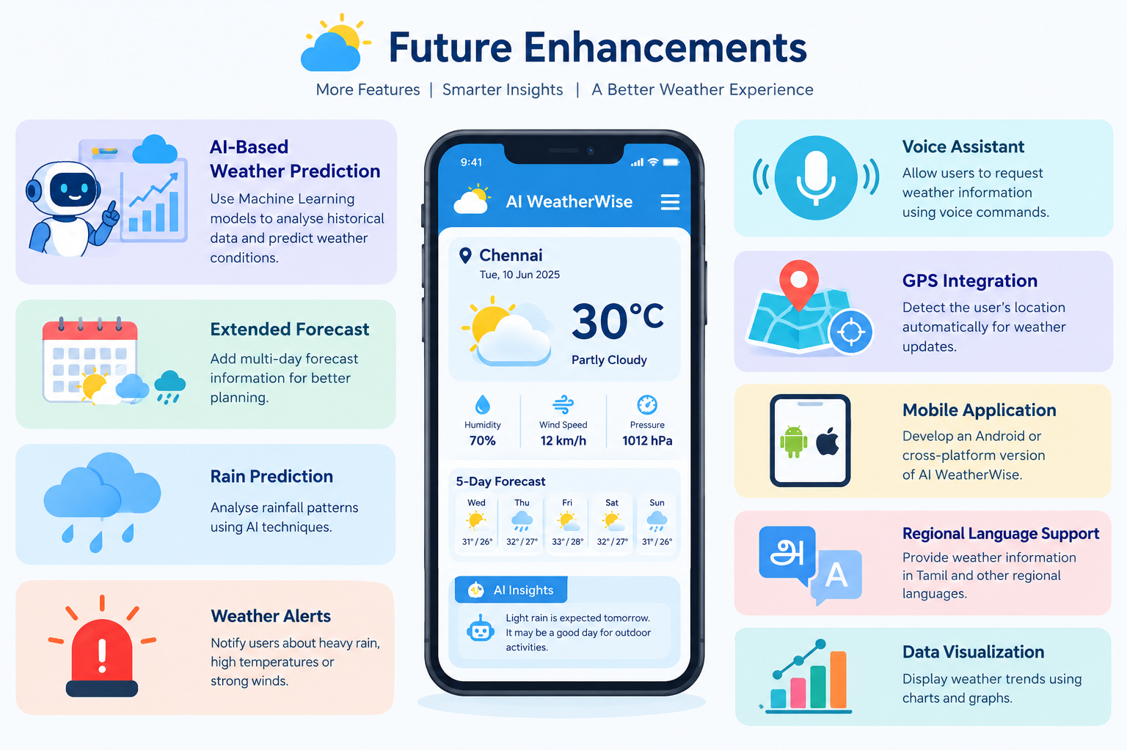
SAMPLE CODING :

import requests
city = input("Enter city name: ")
api_key = "YOUR_API_KEY"
url = "https://api.openweathermap.org/data/2.5/weather"
params = {
"q": city,
"appid": api_key,
"units": "metric"
}
response = requests.get(url, params=params)
data = response.json()
if response.status_code == 200:
print("Weather Information")
print("City:", city)
print("Temperature:", data["main"]["temp"], "°C")
print("Humidity:", data["main"]["humidity"], "%")
print("Wind Speed:", data["wind"]["speed"], "m/s")
print("Condition:", data["weather"][0]["description"])
else:
print("City not found")
OUTPUT :
Enter city name: Chennai

Weather Information
City: Chennai
Temperature: 30.5 °C
Humidity: 72 %
Wind Speed: 4.1 m/s
Condition: clear sky

CONCLUSION
AI Weatherwise is a web-based weather application developed to collect, process, and display weather information through a Weather API. The system allows users to enter a location, retrieves the required weather data, processes the JSON response, and presents important information in a simple and understandable manner.
In future versions, AI and Machine Learning can be used to analyse historical weather data, identify weather patterns, generate predictions, and provide intelligent weather insights.

